Vilas et al. 2025 ICES JMS — Corrigendum Package
Oct 7, 2026

Scope and scientific-audit summary
The published RRMSE of CV used the wrong order of operations: it took the square root of each squared deviation first, then averaged those square roots across replicates. That is mean absolute error, not root-mean-squared error, the two only agree when every deviation has the same sign, which is not the case here. The correct formula averages the squared deviations first, then takes one square root of that average:
$${RRMSE}_{\text{published (wrong)}}=\frac{1}{n}\sum_{i=1}^{n}{\sqrt{{\left({CV}_{,i}−{CV}_{true,i}\right)}^{2}}}$$
$${RRMSE}_{\text{corrected}}=\sqrt{\frac{1}{n}\sum_{i=1}^{n}{{\left({CV}_{,i}−{CV}_{true,i}\right)}^{2}}}$$
where CVsim,i is the simulated CV of the abundance index for replicate i and CVtrue,i is the corresponding true CV, n being the number of replicates per species/year/design combination. The published values systematically understated the true variability. The formula was corrected and the values recomputed directly from the cached simulation outputs. The same underlying simulations, re-aggregated correctly, for both the historical and projected periods.

Key findings from the revision:
- The corrected equation changes historical RRMSE (16-26%) and projected RRMSE estimates (2-2.5%) but with comparable confidence intervals (up to +75%).

OLD – FIGURE 7 RRMSE OF CV HISTORICAL
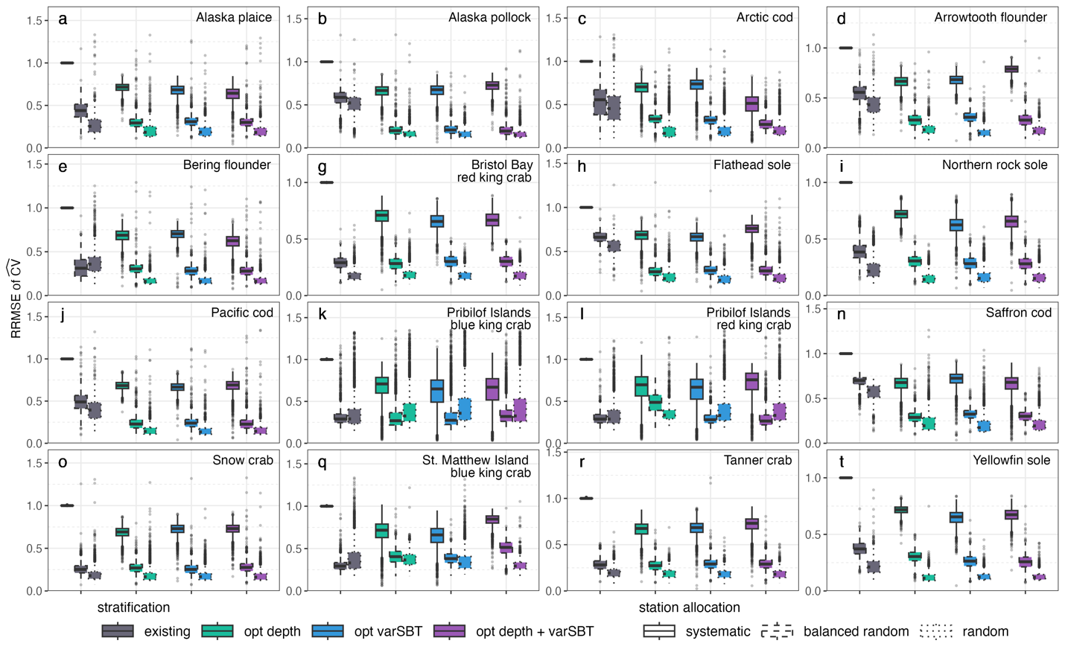

NEW – FIGURE 7 RRMSE OF CV HISTORICAL
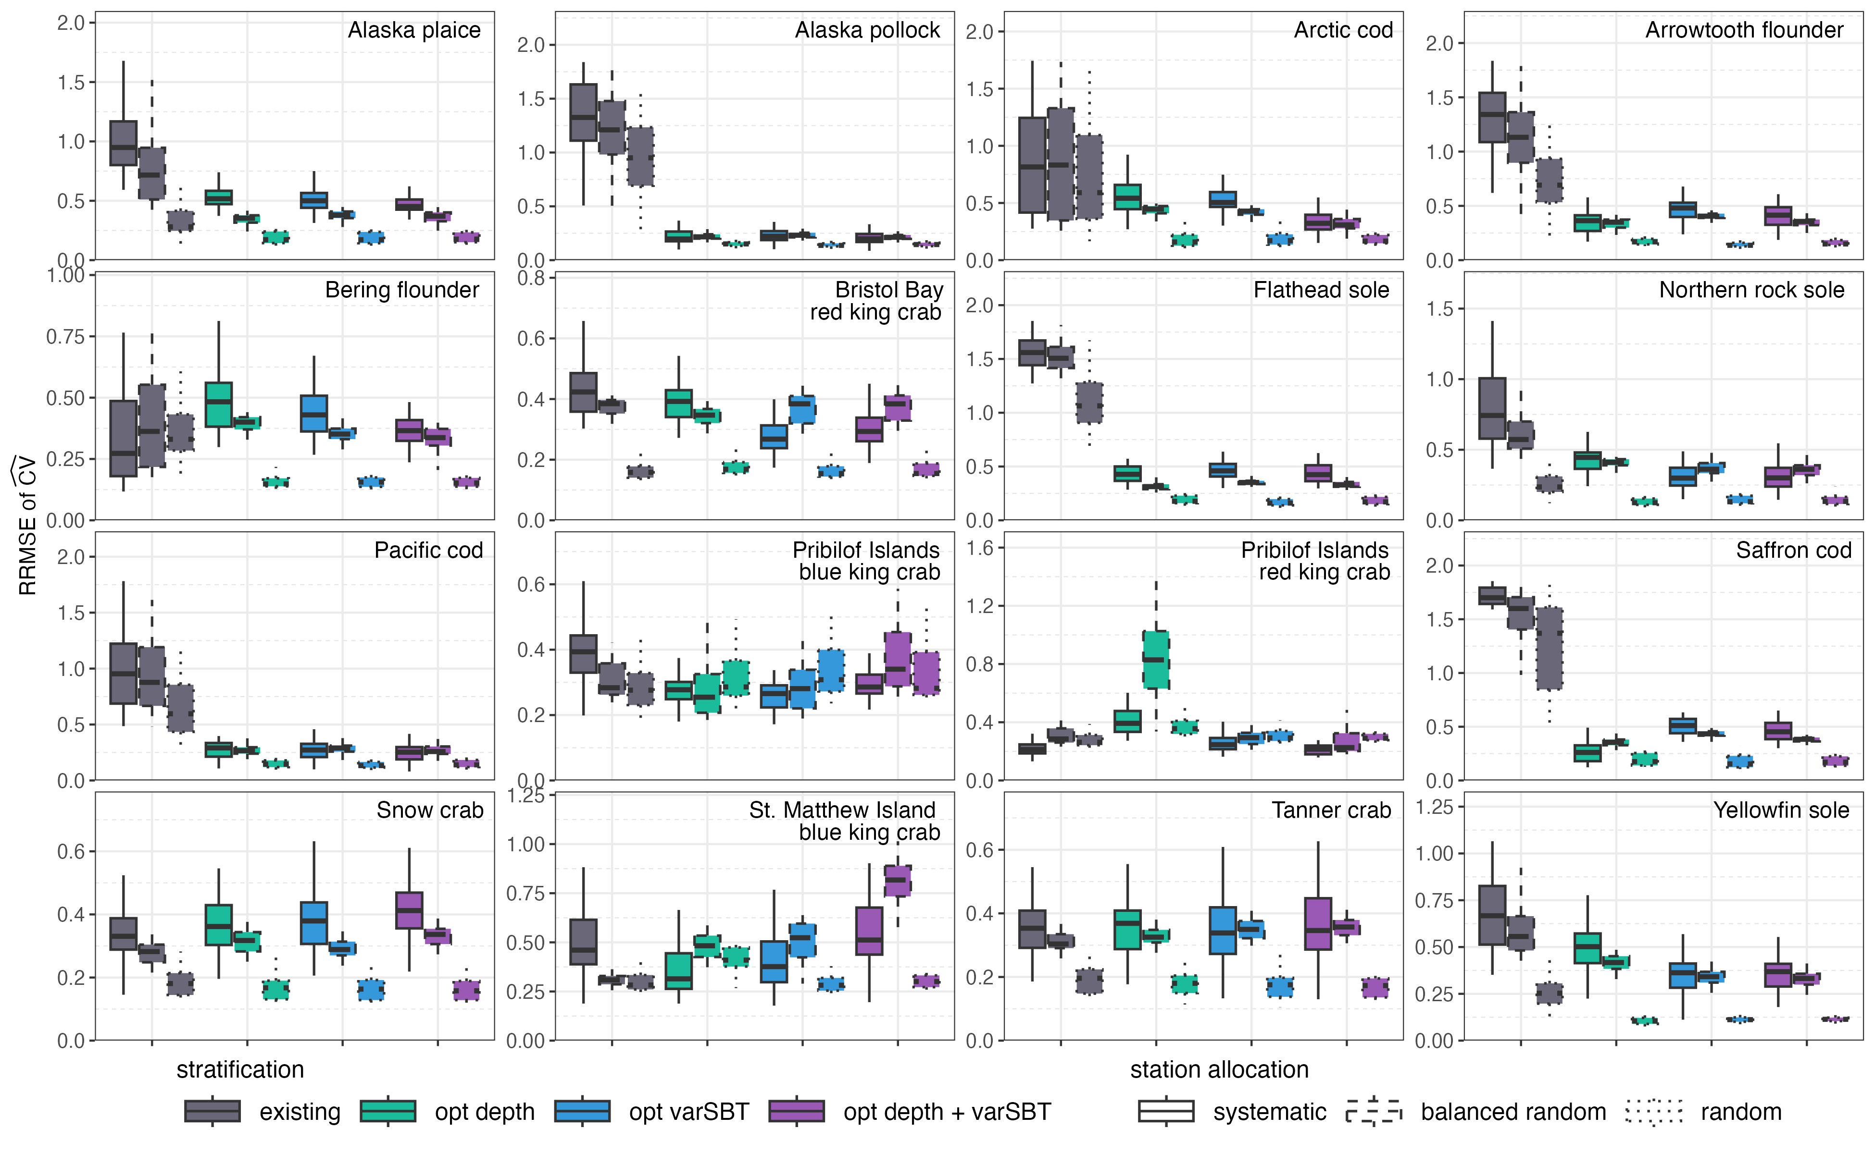

OLD – FIGURE S16 RRMSE CV FUTURE

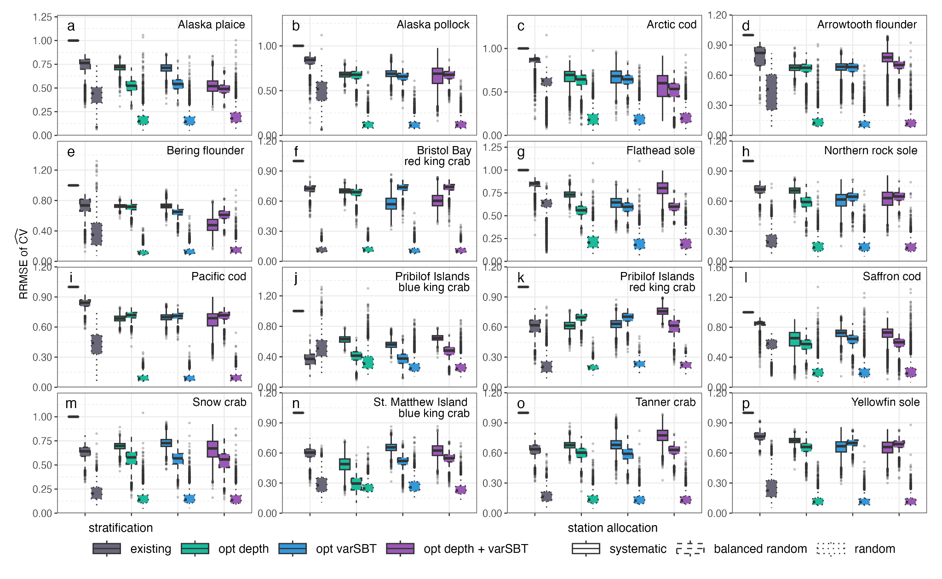
NEW FIGURE S16 RRMSE OF CV FUTURE

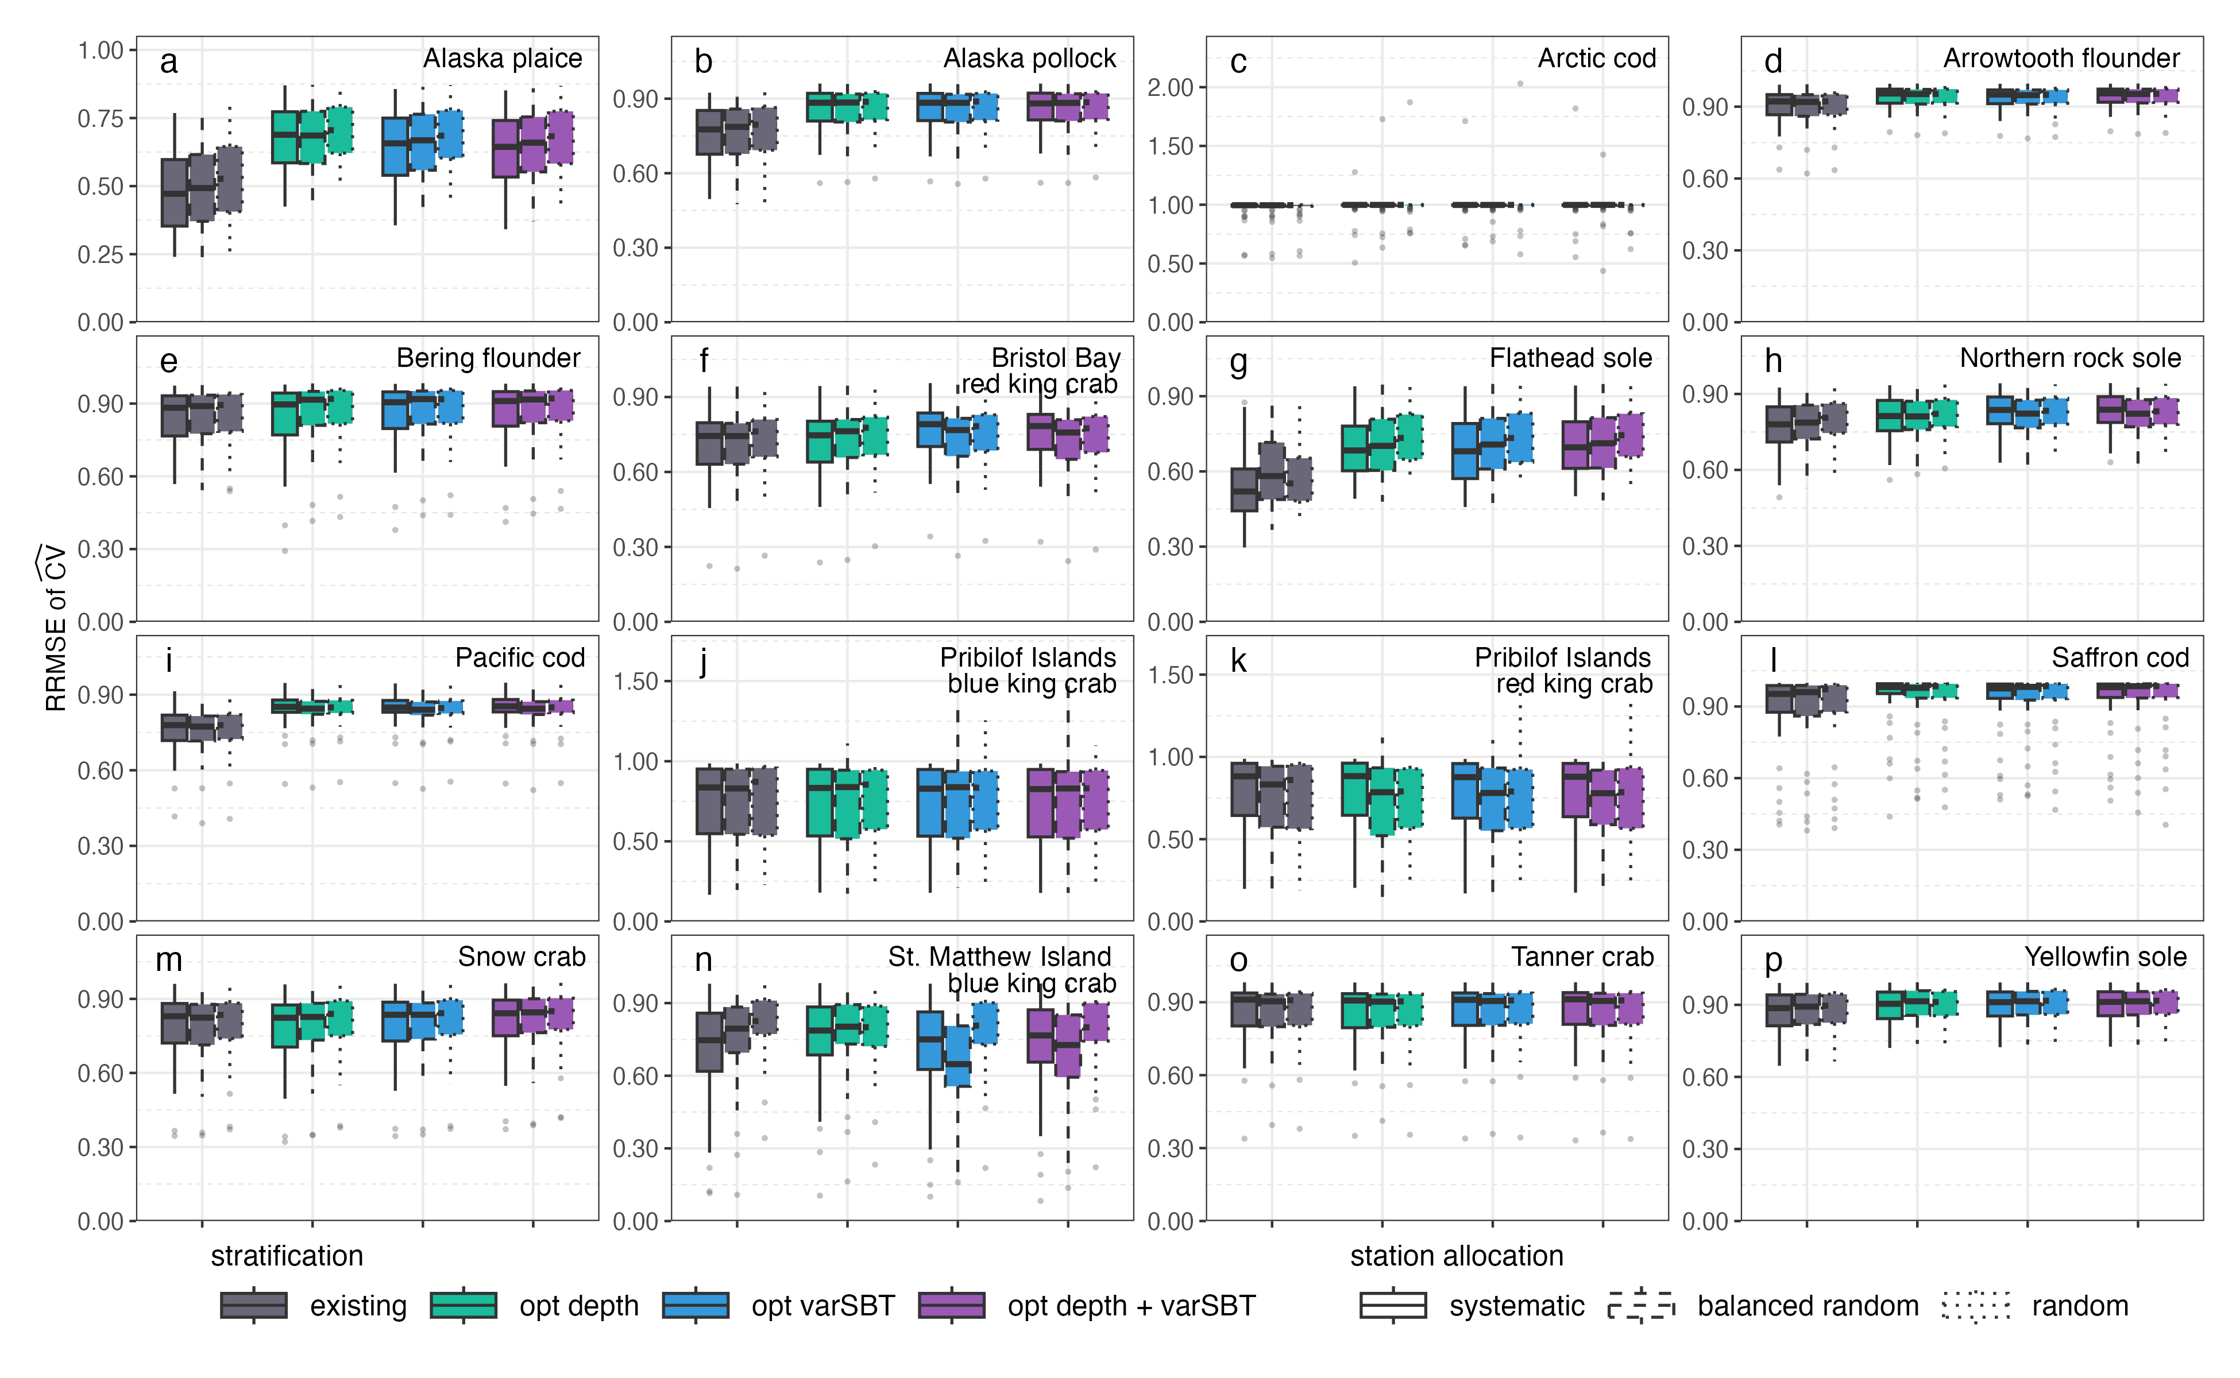

OLD – FIGURE S17 RRMSE OF CV FUTURE BY SBT
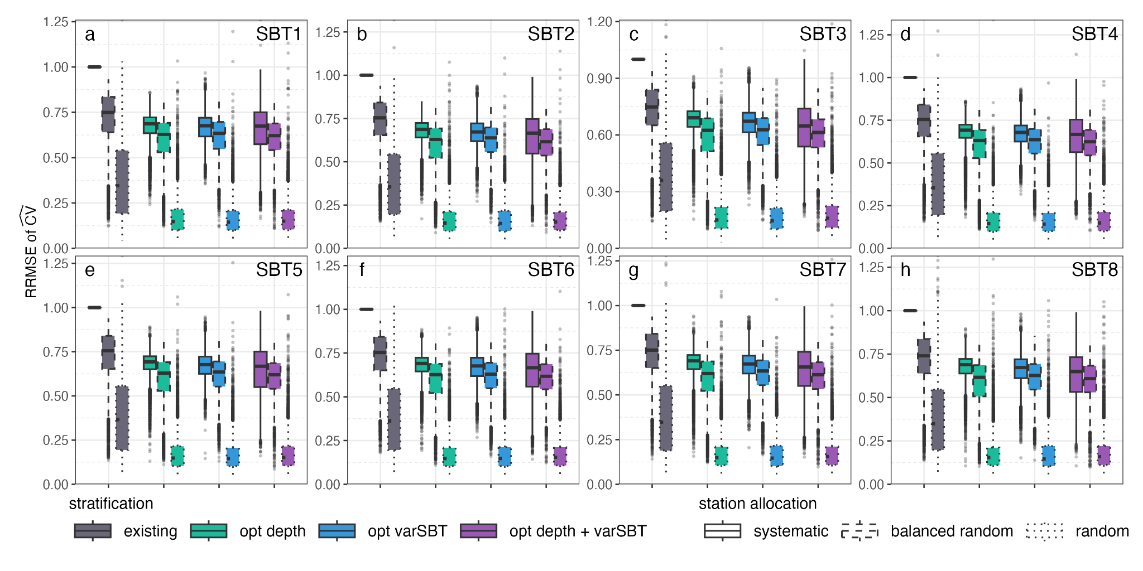

NEW – FIGURE 17 RRMSE OF CV FUTURE SBT
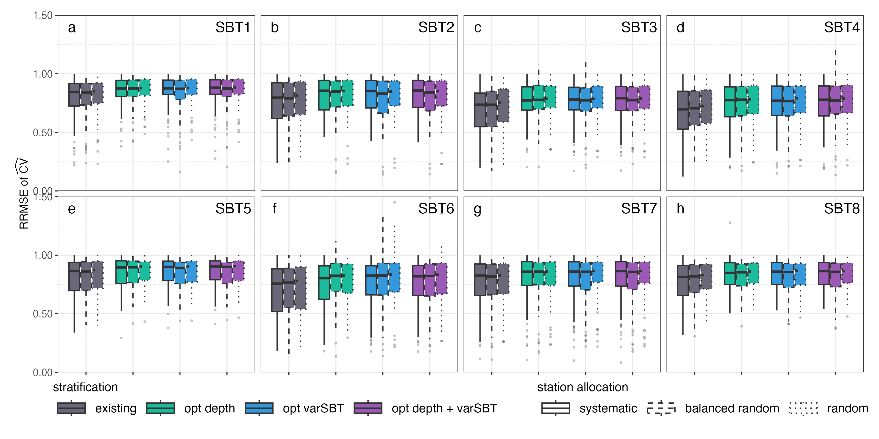

- The published claim "RRMSEs of CV for the existing systematic survey design were 1" does not hold under the corrected equation in either period. This argument was removed from the manuscript since this behaviour is not shown.
- The historical RRMSE of CV survey design ranking holds under the corrected equation, but it increases relative to the published. Published and Corrected: Random allocation most accurate, systematic least accurate
- The projected RRMSE of CV survey design ranking changed under the corrected formula. Published: random allocation most accurate, systematic least accurate (same ranking as historical). Corrected: most species showed similar mean values across survey designs and future scenarios
- The historical "<0.2 for optimized+random" claim holds as a typical/median value.
- The "about 63% of the stocks examined" claim is resolved exactly, straight from the manuscript's own source tables. Supplementary Table S1 (historical mean CV, existing vs. optimized design, by stock) shows 10 of 16 stocks with lower CV under the optimized design; Supplementary Table S3 (the projected-period equivalent) shows 11 of 16 — the only stock differing between the two tables is Hippoglossoides robustus (Bering flounder), FALSE in Table S1 but TRUE in Table S3. The Abstract's phrasing ("historical and projected... for 10 of 16") is the intersection of the two tables' TRUE stocks, which is exactly 10 of 16 — an exact match to the published figure, not an approximation. (An earlier code-based reconstruction from the cached CV data independently landed on 11 of 16, a near-exact but not perfect match; it is superseded by this direct source-table check, which reproduces the manuscript's own underlying tables rather than approximating its method.) This confirms the "about 63%" figure is a CV-magnitude (precision) count — the same metric behind Fig. 6, S11, S14, and S15, all CV distribution plots, and Tables S1/S3 themselves — entirely separate from RRMSE of CV, unaffected by the RRMSE formula bug, and needs no correction. Separately, the Abstract's claim that accuracy "was always lowest for systematic...and highest for random or balanced random" still repeats the Results-section ranking overgeneralization (C4) and needs the fix in C7.

Correction table
ID | Location | Published value/claim | Corrected value | Reason | Other affected sections | Effect on conclusions
C1 | Results, p.7 ("Historical performance...") | "RRMSEs of CV for the existing systematic survey design were 1" | Non-degenerate distribution, sys+existing: historical min 0.12, median 0.62, mean 0.74, max 1.85; projected min 0.12, median 0.79, mean 0.74, max exactly 1.00 (the exact 1.00 ceiling is itself curious but not examined further here) | RRMSE used MAE (sqrt before averaging) instead of RMSE (average before sqrt); formula corrected | Fig. 7; Discussion passage on systematic design | No deterministic "=1"; existing design's precision is variable, not fixed
C2 | Fig. 7, p.8 | Historical RRMSE boxplots per stock/design | Regenerated boxplots (already produced) | Same fix as C1, applies to all designs/species | Any text summarizing Fig. 7 | Ranking (systematic least accurate) still holds historically — see C-ranking note below
C3 | Results, p.7–8 ("Future performance...") | "Optimized survey designs typically led to similar or slightly lower RRMSEs than the existing survey design" | Optimized (scn1–3) RRMSE is higher than existing (scnbase) across all three allocation methods: ~0.79–0.82 (optimized) vs. ~0.74–0.77 (existing) | Same RRMSE fix, projected period | Figs S16, S17; Discussion paragraph on projected-vs-historical similarity; Conclusions sentence on future climate scenarios | Central forward-looking claim ("optimization helps under future climate scenarios") is not supported by corrected RRMSE
C4 | Results, p.7–8 ("Future performance...") | "Random sampling within strata led the greatest accuracy (lowest RRMSE), while systematic sampling provided the least accurate CVs" (projected) | Reversed: random is now least accurate (mean RRMSE 0.794); balanced-random and systematic are statistically indistinguishable (0.777 each) and both more accurate than random | Same fix | Figs S16, S17; "Patterns...were also similar to the historical CVs results" sentence | Design-ranking claim for the projected period is false as published; must be rewritten, not just re-numbered
C5 | Results, p.7 | "Accuracy of the CV was highest...for...random station allocation (<0.2)" (historical) | Median RRMSE 0.164–0.170 for scn1–3+random (holds as typical value); only 64–68% of individual species/year cells fall below 0.2; scn3 mean is 0.203 | Same fix | — | Directional claim holds; wording should say "median" rather than an absolute "<0.2" bound
C6 | Discussion/Conclusions, p.8–9 | "A new optimization approach can provide a similar or higher degree of precision and accuracy than the existing survey design for historical conditions and under future climate scenarios for about 63% of the stocks examined" | Resolved exactly, from the manuscript's own source tables. Supplementary Table S1 (historical mean CV, existing vs. optimized design, by stock) shows 10 of 16 stocks with lower CV under the optimized design; Table S3 (the projected-period equivalent) shows 11 of 16, differing from Table S1 only in Hippoglossoides robustus (Bering flounder). The Abstract's "10 of 16" is the intersection of the two tables' TRUE stocks — exactly 10, an exact match to the published figure. (A prior code-based reconstruction from the cached CV data landed on 11 of 16, a near-exact approximation now superseded by this direct source-table check.) This is a CV-magnitude (precision) metric — also the metric behind Fig. 6, S11, S14, S15 and Tables S1/S3 themselves, none of which are RRMSE figures — independent of the RRMSE-of-CV formula bug, and does not need correction. | Different metric than C1–C5: compares the magnitude of CV between designs (precision), not the accuracy of the CV estimate (RRMSE of CV). The formula bug was isolated to RRMSE-of-CV averaging, so this count is not expected to be affected by it. | Conclusions | The "63%" figure itself is confirmed (to high confidence) unaffected by the RRMSE formula bug and needs no correction. The Abstract's separate "always lowest...highest" ranking sentence, however, still makes the same overgeneralized claim as C4 and needs the same correction — see C7.
C7 | Abstract | "The accuracy of the estimate of abundance precision was always lowest for systematic sample allocation and highest for random or balanced random sampling within strata" | Holds historically only. Under the corrected projected-period RRMSE, random is least accurate (mean 0.794) while balanced-random and systematic tie as most accurate (0.777 each) — the reverse of what "always" claims | Same RRMSE fix as C4; the Abstract states the historical-period pattern as if it held in every period | Results/Discussion passage already flagged in C4 | The Abstract is the first text an editor or reader sees; it needs the same correction as C4 regardless of how the Results-section wording is revised
Note on ranking (C2): historical mean RRMSE by allocation (pooled across stratifications): random 0.32, balanced-random 0.48, systematic 0.51 — ranking unchanged from published. Projected: balanced-random 0.777, systematic 0.777, random 0.794 — ranking reversed from published, and from the historical pattern.
[embed: node/c11de79d-7a70]
Random is the most accurate design historically and the least accurate under the projected scenario; balanced-random and systematic trade places with it, converging to a statistically indistinguishable mean (0.777) as random rises to 0.794.

Corrected manuscript text

Results — Historical performance (p.7)
Published: "Accuracy of the CV was highest (RRMSE lowest) for the optimized survey designs using random station allocation (<0.2), followed by balanced random, while systematic sampling provided the least accurate CVs. Sampling stations for the existing systematic survey design are fixed so they are resampled in each simulated survey and RRMSEs of CV for the existing systematic survey design were 1."
Corrected: "Accuracy of the CV was highest (RRMSE lowest) for the optimized survey designs using random station allocation (median RRMSE 0.16–0.17), followed by balanced random, while systematic sampling provided the least accurate CVs (mean RRMSE 0.51 vs. 0.48 for balanced random and 0.32 for random, pooled across stratifications). For the existing systematic survey design, RRMSE of CV ranged from 0.12 to 1.85 across stocks and years (mean 0.74, median 0.62), reflecting real variability rather than a fixed value."

Results — Future performance (p.7–8)
Published: "Patterns of the accuracy of CVs (RRMSE of CVs) were also similar to the historical CVs results (Supplementary Figs S16 and S17). Optimized survey designs typically led to similar or slightly lower RRMSEs than the existing survey design. More striking were the differences in RRMSE among station allocation methods, where random sampling within strata led the greatest accuracy (lowest RRMSE), while systematic sampling provided the least accurate CVs, but not much worse than balanced random sampling."
Corrected: "Patterns of the accuracy of CVs (RRMSE of CVs) differed from the historical results (Supplementary Figs S16 and S17). Optimized survey designs showed higher (less accurate) RRMSEs than the existing survey design under projected conditions (mean RRMSE ~0.80–0.82 for optimized designs vs. ~0.74–0.77 for the existing design, pooled across allocation methods). The ranking among station allocation methods also differed from the historical period: random sampling within strata, which was most accurate historically, was the least accurate under projected conditions (mean RRMSE 0.79), while systematic and balanced random sampling were statistically indistinguishable from each other (mean RRMSE 0.78 each) and both more accurate than random. This reversal is likely connected to the substantially higher uncertainty in the projected abundance indices relative to the historical period (Supplementary Figs S13 and S14)."

Discussion (p.8–9)
The existing Discussion paragraph on systematic sampling's known lack of a valid design-based variance estimator (citing von Szalay et al. 2023; Strand 2017) remains applicable and requires no change. We recommend adding a sentence acknowledging the projected-period ranking reversal and flagging it as an area needing further investigation, e.g.: "The reversal of the station-allocation ranking under projected conditions, relative to the historical period, suggests that the relative performance of station allocation methods may itself be sensitive to the magnitude of underlying biomass projection uncertainty, warranting further investigation."

Conclusions (p.9–10)
Published: "A new optimization approach can provide a similar or higher degree of precision and accuracy than the existing survey design for historical conditions and under future climate scenarios for about 63% of the stocks examined."
Status: The "historical conditions" portion is resolved exactly — the 63%/10-of-16 claim is confirmed directly from the manuscript's own Supplementary Tables S1 (historical, 10 of 16 TRUE) and S3 (projected, 11 of 16 TRUE; intersection with S1 = exactly 10 of 16) and does not need correction. The "under future climate scenarios" portion is not supported by the corrected RRMSE results (C3, C4) and needs to be removed or substantially qualified. Suggested replacement (for author review): "A new optimization approach can provide a similar or higher degree of precision and accuracy than the existing survey design for historical conditions for about 63% of the stocks examined; under projected future conditions, however, the relative accuracy of station-allocation methods reverses, and optimized designs do not reduce RRMSE of CV relative to the existing design." XXXX — co-authors to review and finalize this replacement wording.

Draft corrigendum letter (to the handling editor)
For Daniel/Lewis to finalize on letterhead/via the journal's editorial system — addressed to Olav Rune Godø, Handling Editor, ICES Journal of Marine Science.

Subject: Request for corrigendum — Vilas et al. 2024, "Optimized stratified random surveys best estimate multispecies abundance in a rapidly changing ecosystem," ICES Journal of Marine Science 82(6): fsae158, DOI 10.1093/icesjms/fsae158
Dear Dr. Godø,
We are writing to request a corrigendum for the above article. During subsequent analysis, we identified an error in the calculation of the relative root mean squared error (RRMSE) of the estimated coefficient of variation (CV), reported in Figure 7 and Supplementary Figures S16–S17, and discussed in the Results and Discussion sections.
The RRMSE was calculated by taking the square root of each squared deviation before averaging across replicates, which computes the mean absolute error rather than the root mean squared error (as the two differ whenever deviations vary in magnitude, per Jensen's inequality). We have corrected the calculation to average the squared deviations before taking the square root, consistent with the formula as stated in the Methods (p.6).
The correction affects:
- Figure 7 and the associated Results text describing historical RRMSE, including the statement that RRMSE for the existing systematic survey design was exactly 1 for all stocks;
- Supplementary Figures S16 and S17 and the associated Results text describing projected-period RRMSE patterns;
- A statement in the Results comparing the accuracy of station allocation methods under projected conditions, which we found reverses under the corrected calculation (random allocation, reported as most accurate, is now the least accurate; systematic and balanced-random allocation are statistically indistinguishable);
- The Conclusions statement regarding optimization performance under future climate scenarios, which is not supported once the RRMSE values are corrected.
We have verified the correction against the full simulation output and prepared updated figures, tables, and text (attached/available on request). We propose [a corrigendum / an erratum — per journal convention] covering the items above, and are glad to work with you and the reviewers on the appropriate format and scope.
We apologize for the error and appreciate your guidance on next steps.
Sincerely, Daniel Vilas XXXX — confirm whether to sign on behalf of all co-authors or list each co-author individually, per the item below

Open before sending: XXXX — (a) confirm whether ICES JMS/Oxford Academic has a specific corrigendum submission portal distinct from the manuscript system (no journal-specific guidance was found via web search, so this likely goes through the standard editorial contact); XXXX — (b) confirm whether all co-authors should be copied or need to co-sign per journal policy. (c) is resolved: the "63% of stocks" item (C6) has been reconstructed to high confidence and does not need correction.

Draft reply email to Lewis Barnett

Subject: Re: RRMSE results — bigger than a projection-uncertainty story
Hi Lewis,
Thanks for the quick look, and no worries on the delay. I dug into the projection-period RRMSE differences you flagged, and it turned out to be bigger than "no differences among designs because of projection uncertainty."
The core issue: the RRMSE calculation itself had a formula bug. It took the square root before averaging across replicates — that's mean absolute error, not the root-mean-squared error the Methods section describes (square-root and averaging don't commute). The fix squares the deviations first, averages those, then takes one square root of the average. I recalculated it correctly directly from our cached simulation outputs, so no new simulations were needed.
Two things came out of this, beyond what you guessed:
- Historically, the fix shifts RRMSE up by quite a bit more than I expected — 16–26% on average depending on station allocation, with some individual species/year cells shifting over 100%. The "existing+systematic RRMSE = 1" result in the Results section doesn't hold either — the corrected distribution is real and ranges from 0.12 to 1.85, not a flat line. I haven't been able to fully explain why the original figure came out perfectly flat at exactly 1 for every stock, since neither the old nor the corrected formula reproduces that on the current simulation outputs — if you remember anything about how CV_sim was computed for the existing design specifically (beyond the RRMSE averaging step), let me know, otherwise I think we just state the corrected numbers and don't speculate on the original mechanism.
- For the projected period — this is the one I think needs your eyes before anything goes to Olav: the design ranking reverses. Published: random allocation was most accurate, systematic least accurate, matching the historical pattern. Corrected: random is now the least accurate (mean RRMSE 0.79), and systematic/balanced-random are statistically tied (0.777 each) and both beat random. Optimized stratifications are also now less accurate than the existing design under projected conditions, not similar-or-better. That directly undercuts the "optimization helps under future climate scenarios" framing in the Conclusions.
I don't think this is just a "note it's due to projection uncertainty" fix — it changes a real conclusion, not just a figure's appearance. I've put together a full correction table, draft corrected text, the regenerated Fig. 7/S16/S17, and a draft letter to Olav here: [link to this doc]. Before I send anything to the editor, I need you to look specifically at the "Note on ranking (C2)" section and the three embedded figures right after it and after the Results—Future text, and tell me whether you read the reversal the same way I do: historically random is most accurate and systematic least accurate (Fig. 7); under projected conditions that flips, with random becoming least accurate and systematic/balanced-random converging as the best (and nearly indistinguishable from each other) in Figs. S16 and S17. If you agree, I'd also like your take on how we frame the Conclusions change — I've drafted a replacement sentence there for review.
(The "63% of stocks" question I'd flagged earlier is resolved — turns out it's a CV-magnitude statistic, not RRMSE, and I confirmed it directly against the manuscript's own Supplementary Tables S1 and S3, which reproduce the published "10 of 16" exactly. No action needed from you there.)
Let me know when you have a few minutes to look at the doc.
Thanks, Daniel

Open items requiring author/co-author input
- RESOLVED — the "63% of stocks" claim (item C6) is confirmed exactly from the manuscript's own Supplementary Tables S1 and S3 (intersection of their TRUE stocks = exactly 10 of 16, matching the published figure precisely, not an approximation); no further numeric work needed here, only the Conclusions wording decision in the Status note above.
- XXXX — Lewis to review the projected-period ranking reversal (item C4) before the letter to the editor is sent — this changes a substantive conclusion, not just a number
- XXXX — confirm whether ICES JMS/Oxford Academic has a dedicated corrigendum submission process, or whether the handling editor should be contacted directly first
- XXXX — decide whether all co-authors need to review/co-sign the corrigendum letter before submission
- RESOLVED — corrected Figures 7, S16, and S17 have been regenerated (from the fixed RRMSE formula, reusing the cached simulation outputs) and are now embedded above under the C2 and C3/C4 notes. Tables S1–S3 are CV-magnitude tables, unaffected by the formula bug, and need no regeneration.
- XXXX — re-confirm GitHub repository code (https://github.com/Lewis-Barnett-NOAA/Bering_redesign) is updated to the corrected formula before the corrigendum states the code has been fixed

